**Lab - 07**

**Introduction to TCP(Transmission Control Protocol) and Analysis using Netsim**

**Program: MScIT**

**Sem-2**

**Group ID : 28**

**Student Name Student ID**

Dev Adnani 202212012

Saif Saiyed 202212083

**2.1.1 Experiment**

To encounter three way handshaking perform the steps mention below.

1. Establish topology shown in figure 2, with two wired node, one router with HTTP application between

two nodes.

2. Set parameters for application: Application Method: Unicast and END Time(s): 10

3. Run simulation for 5 second.

4. Open packet trace file and Consider following Columns: PACKET ID, PACKET TYPE,

CONTROL PACKET TYPE, DESTINATION ID, TRANSMITTER ID,RECEIVER ID,

SEQ NO, is Syn,is Ack,is Fin, SEGMENT lEN, Remove rest of the columns.

5. Filter PACKET TYPE by selecting only Control Packets.

6. After filter, you can see the SYN flag transmitted from Node 2 to Node 1 through Router, analyze the value of is Syn and is Ack columns.|  
  
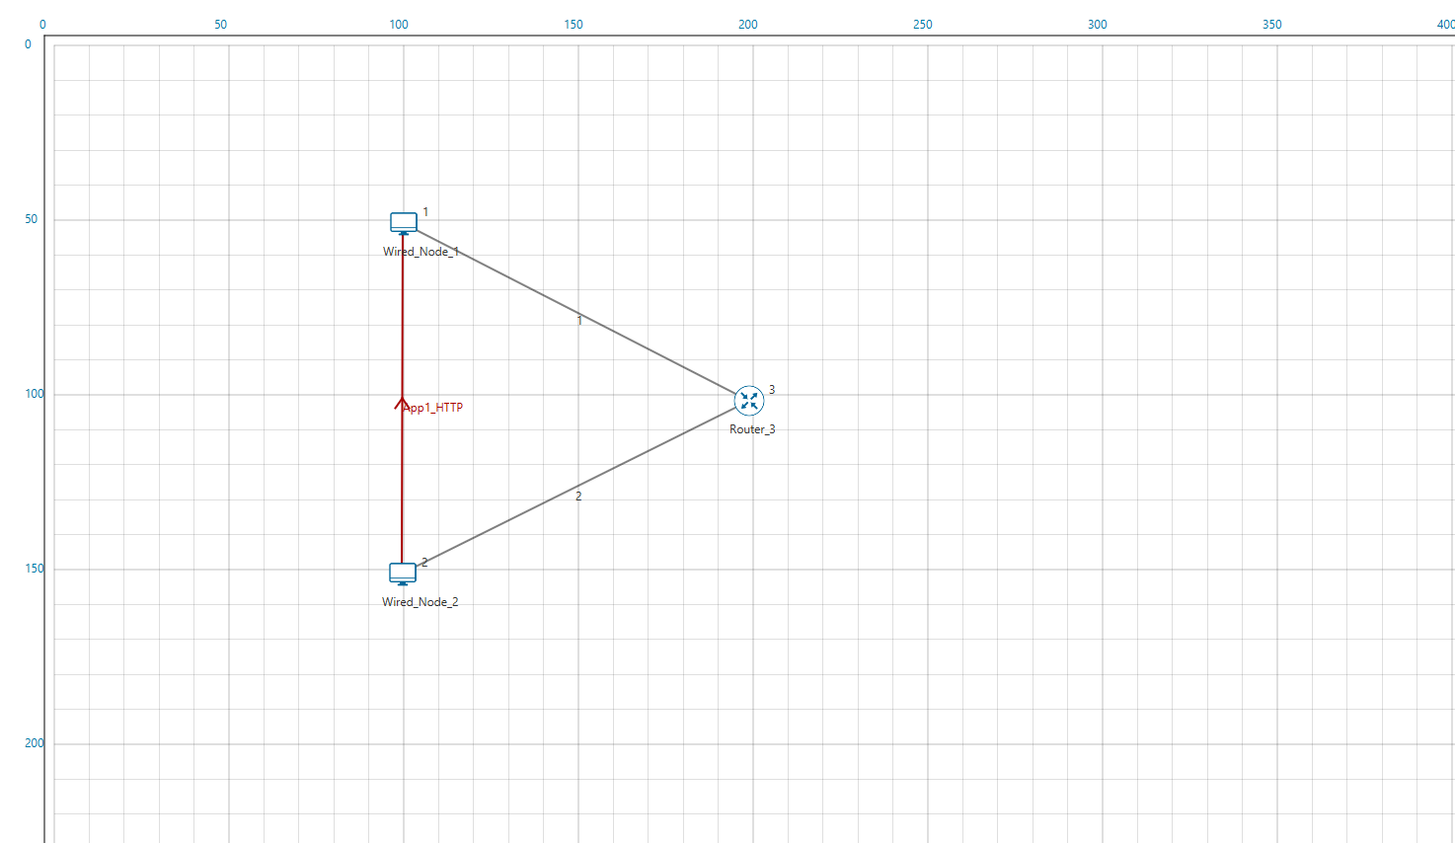

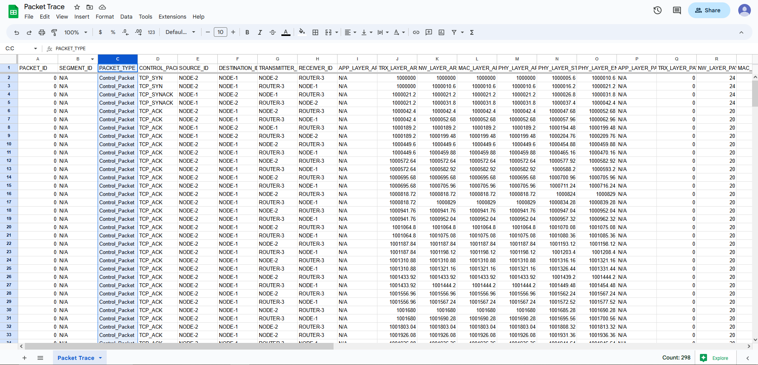

**2.1.1 Experiment**

1. After connection establishment, continue with the same packet trace file, Add one

more filter, CONTROL PACKET TYPE: TCP ACK and TCP FIN

  
  
2. You can see the FIN flag transmitted over destination through router, analyze the value of is Fin and is Ack

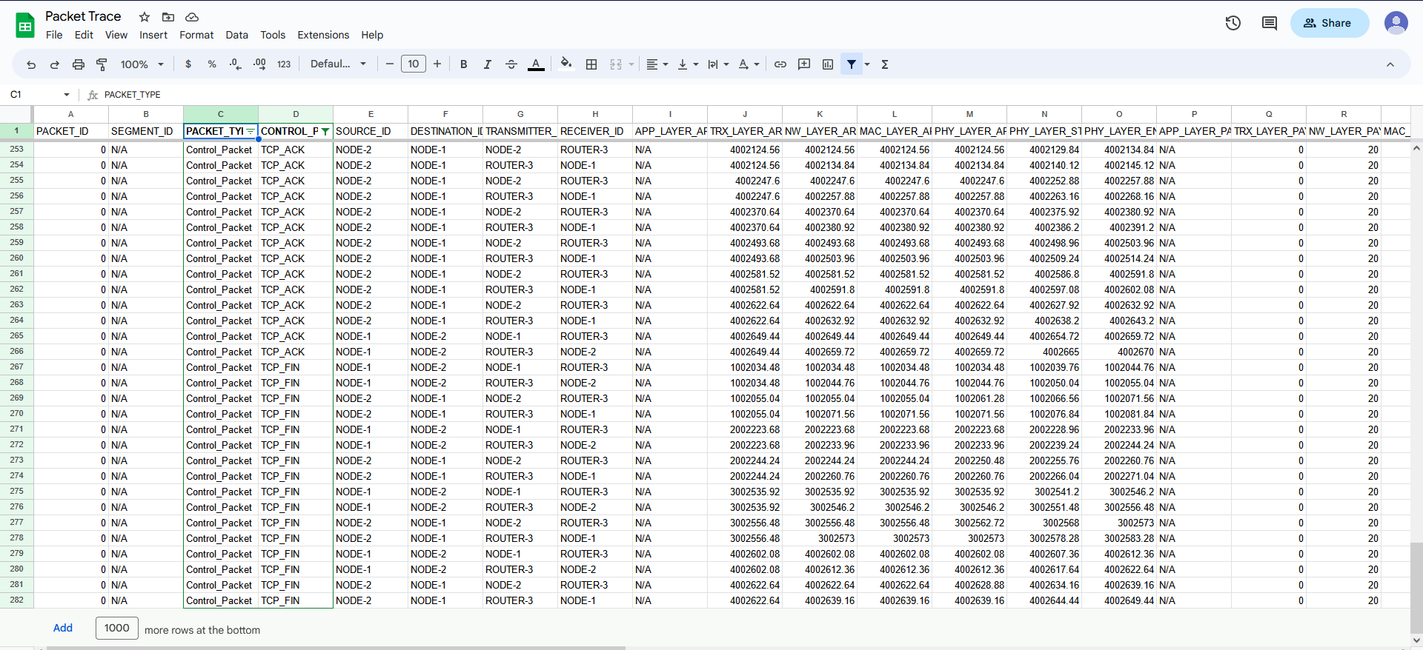

isSyn: True

isAck: False

**2.3 Exercise**

1. What is the Sequence number of the 1st SYN control packet and its acknowledgment?

Answer : Sequence number is 250000 and acknowledgment is false

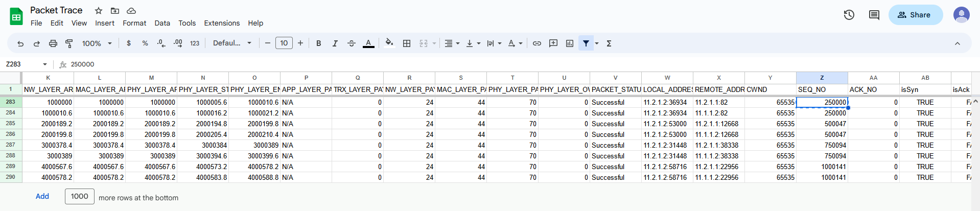

2. What is the sequence number of the 1st FIN control packet and its acknowledgement?

Answer : sequence number is 270006 and acknowledgement is false

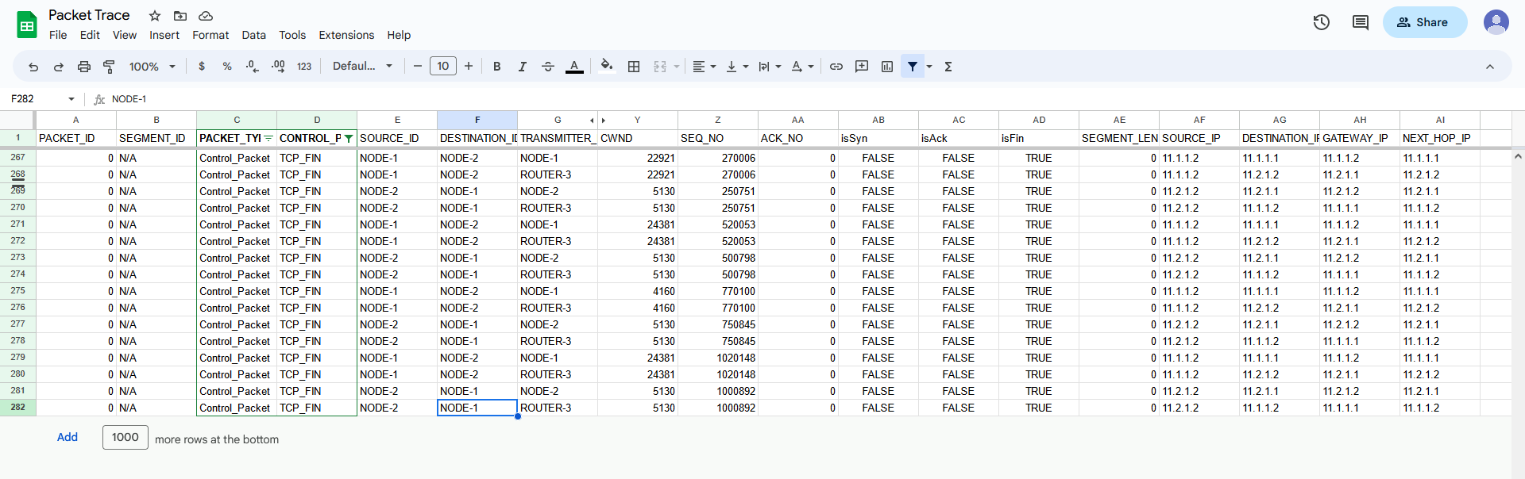

3. Draw the Diagram of Connection establishment and termination as shown in figure 1

and 3 only with sequence number of each packet in you log book.

Answer :

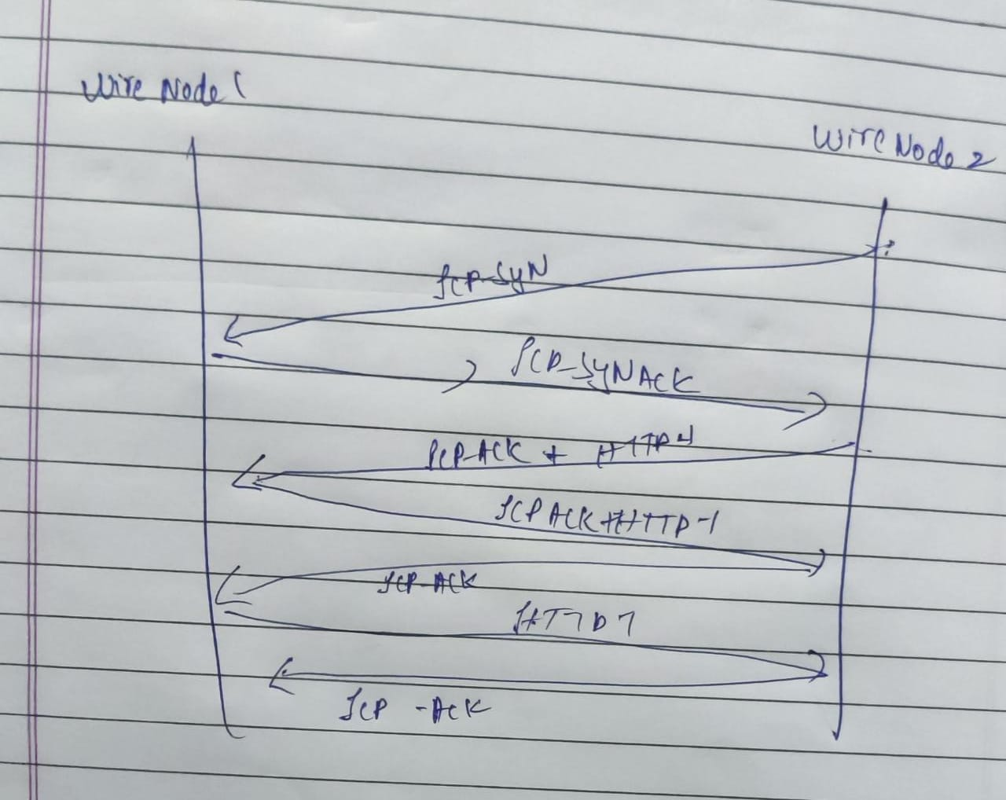

4. Why TCP uses 4 way finishing for connection termination instead of 3way like

connection establishment?

Answer :

TCP uses a 4-way handshake for connection termination to ensure that both the client and server have completely closed the connection and that all data has been successfully transferred.

In a 3-way handshake for connection establishment, the client sends a SYN packet to the server, the server responds with a SYN-ACK packet, and the client sends an ACK packet to confirm the connection.

During a connection termination, the client sends a FIN packet to the server to indicate that it has no more data to send. The server then responds with an ACK packet to confirm that it has received the FIN packet. However, the server may still have data to send to the client, so it sends a FIN packet to the client to indicate that it has no more data to send. Finally, the client responds with an ACK packet to confirm that it has received the FIN packet.

By using a 4-way handshake, TCP ensures that all data has been successfully transmitted and acknowledged by both parties before the connection is fully terminated.

This helps to avoid potential data loss or corruption that could occur if the connection was terminated abruptly with a 3-way handshake.

5. How many sessions it takes to transfer all data in this application?

Answer : Total 130 http sessions

6. Save this experiment as EX:1 for further lab session.

Saved

7. Start new experiment. Consider the same topology and configuration of EX: 1. Modify the property of link 1 according to this, Set Uplink Bit Error Rate and Download Bit Error Rate: 0.00001, Uplink Propagation Delay and Download Propagation Delay: 10 microsecond. Run the simulation for 10 seconds. Observe all rows of PACKET ID:1 with SEGMENT ID 1,2. Draw the diagram of transmission of packet id 1 for segment no 1 and 2 until successfully received with sequence number and acknowledgement number.

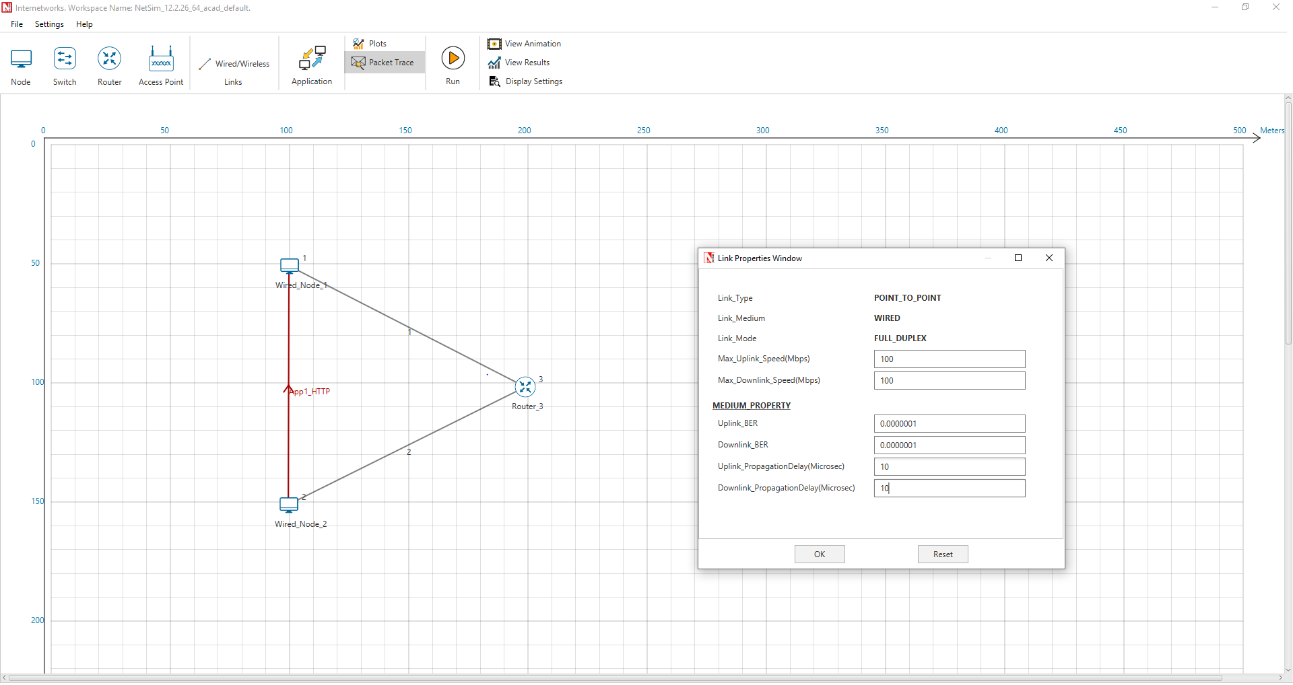





8. The data transfer initiated by from node 1 to node 2. If SYN packet have sequence number 5460, there were 5000 bytes of total data transmitted through network in one session, maximum segment size were 1500 bytes then what will be the sequence number of last packet and FIN packet?

SYN packet sequence number = 5460

Total data transmitted = 5000 bytes

Maximum segment size = 1500 bytes

To calculate the sequence number of the last packet, we need to divide the total data by the maximum segment size and round up to the nearest integer to determine the total number of packets needed for transmission:

Total number of packets = ceil(5000/1500) = 4

To calculate the sequence number of the last packet, we need to add the sequence number of the first packet (SYN packet) and the cumulative size of all packets except the last one (3 packets x 1500 bytes/packet = 4500 bytes), and then add the size of the last packet: Sequence number of last packet = 5460 + 4500 + 500 = 10460

To calculate the sequence number of the FIN packet, we need to add 1 to the sequence

Number of the last packet:

Sequence number of FIN packet = 10460 + 1 = 10461

Therefore, the sequence number of the last packet is 10460 and the sequence number of The FIN packet is 10461.

**3.1 Experiment**

1. Open Experiment Ex:1

2. Run simulation for 2 seconds.

3. Open packet trace file. filter the field CONTROL PACKET TYPE: APP1 HTTP, HTTP REQUEST

4. Consider PHYSICAL LAYER END TIME, APPLICATION LAYER ARRIVAL TIME,

PHY LAYER PAYLOAD

5. Calculate throughput:

APPLICATION LAYER ARRIVAL TIME - PHYSICAL LAYER END TIME = 17003288- 21509980.08

Fix throughput = 24522 / 4506692.08

=0.0054412415

• Fix throughput: Calculate total payload and divide by total difference of time.

(APPLICATION LAYER ARRIVAL TIME - PHYSICAL LAYER END TIME) .

• Moving average throughput

(a) Except APPLICATION LAYER ARRIVAL TIME, PHYSICAL LAYER END TIME,

PHY LAYER PAYLOAD, you can clear all other columns for convince.

(b) Calculate time difference.

(APPLICATION LAYER ARRIVAL TIME - PHYSICAL LAYER END TIME) of 1st 10 rows

and respectively sum of total payload of 1st 10 rows and copy both values in two separate

columns A and B.

(c) Similarly calculate time difference for 2nd to 11th rows and total payload for same rows, then

for 3rd to 12th, 4th to 13th, 5th to 14th, 6th to 15th up to 11th to 20th rows respectively.

(d) In third column C calculate the throughput by dividing total payload bytes (column B) by time

difference (column A).

(e) Select Column C and select the scatter graph with smooth lines and markers.

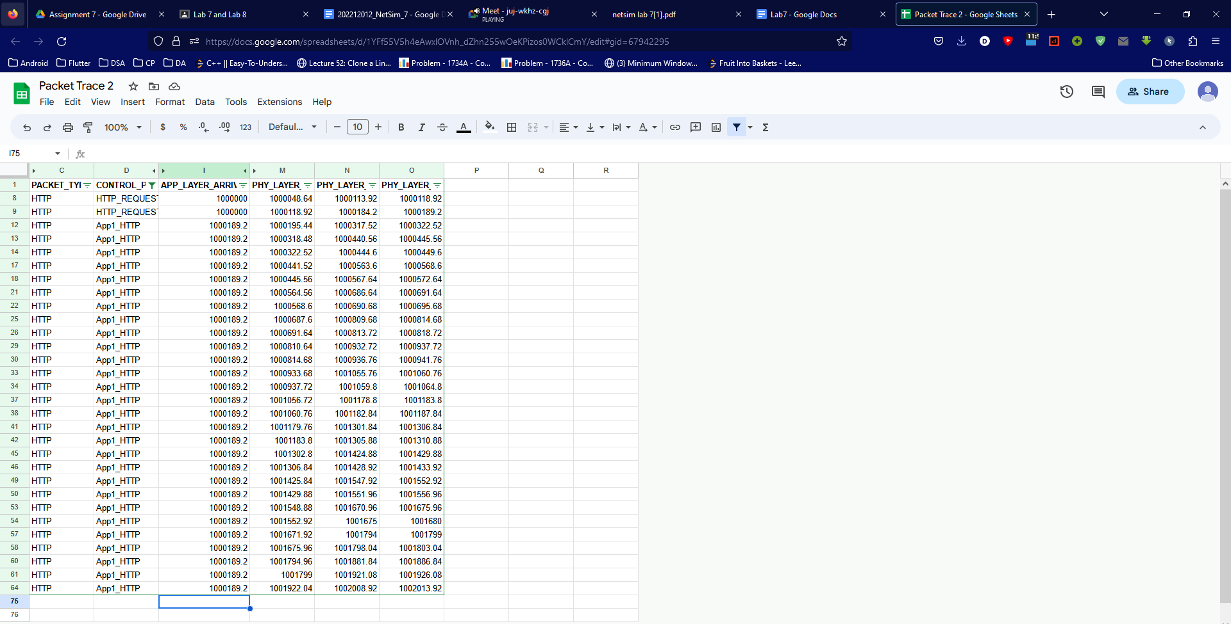

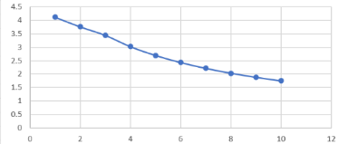

**3.2 Exercise**

1. What is the maximum throughput value, consider the graph.

Answer : 4.124645352

2. Calculate average throughput for the same experiment with simulation time 10 seconds. Is there any difference? Why?

Answer :

If the size and number of packets transmitted increases with longer simulation times, the average throughput may increase as well. This is because more data is transmitted in a longer simulation period, increasing the overall throughput.

= 0.0015376023721994 - 0.000216319722

= 0.0013212826501994

Difference is because with more simulation time then the previous experiment more amount of material will be passed between the two wired nodes resulting in greater throughput.

3. Consider data transmission between 2 device A and B. A have sent a total 1000 bytes of data, Maximum segment size will be 150 bytes. Sending rate of packet 10 bytes/second will be Packet number 2, 4, and 5 got errored. But before termination, Device B have received all 1000 bytes. Calculate the average throughput in unit bits/second.

First, we need to calculate the total number of packets sent by device A:

Total number of packets = Total bytes sent / Maximum segment size

Total number of packets = 1000 bytes / 150 bytes per packet

Total number of packets = 6.67, which we round up to 7 packets

Since packets 2, 4, and 5 were errored, only 4 packets were successfully received by device B.

The time it took for device A to send all 1000 bytes is:

Time = Total bytes sent / Sending rate per second

Time = 1000 bytes / 10 bytes per second

Time = 100 seconds

The throughput is the amount of data transmitted per unit time, and can be calculated as:

Throughput = Total data transmitted / Total time taken

Throughput = 1000 bytes / 100 seconds

Throughput = 10 bytes per second

To convert this to bits per second, we multiply by 8:

Throughput = 10 bytes per second * 8 bits per byte

Throughput = 80 bits per second

Therefore, the average throughput between devices A and B is 80 bits per second